# Database Requirement

## Scenario

John Hopkins Hospital represents the community's psychiatric department Johns Hopkins Hospital Psychiatry Department and Behavioural Sciences treats adults, adolescents, and children in more than a dozen specialist areas.

Need to update the inpatient unit's system and upgrade the mechanism of the way of storing and managing the data of the doctors, nurses, patient, arranging the schedule, to have a flexible medical service record and enter the medical history for the patients.

In order to keep pace with modern systems in the organization and management of information also make expansion constriction for this department and increasing the patients and the medical staff (doctors and nurses) that means increasing the data to deal with.

So to manage all that big amount of data of this department, the Hospital board of directors has decided set a budget to upgrade the database.

In addition, that include graphical interface to be more efficient in using that will be used by the user of the system (nurse, doctor and patients).

Features of the system : nurses will deal with medical service record that the system will make a notification of the kind of the service that will present (checking, food, medical injection, etc.).

**Note**: the system components and features will be mentioned briefly the next section will be in details.

## Data Requirements

1_the hospital has many department, each department has (department ID, name, email, phone) every single department contain many doctors, nurses and patients.

2_ the department has many doctors, each Doctor has (doctor ID, name, gender, date of birth, salary, phone, email, address, degree type, graduated from, the county of the degree, specialty).

3_ the doctor can deal with many patients, each patient has (Patient ID, name, phone, gender, date of birth, salary, address, phones of the first degree relatives, room no, recovery plan number, case description, disease type, medicine ID). In the other side the patient can be treated by one doctor.

4_the patient can get served by one nurse, each nurse has (nurse ID, salary, name, gender, date of birth, phone, email, address, degree type, graduating from, the country of the degree). Nurse can service many patients.

5_the nurses serve the patient based on the medical service recorded to determine the medical service for the patients, the record contain (the medical service record number, date and time, service type).

6_ every patient has a medical service record and managed by one nurse, the nurse can deal with multi medical service record, and the medical service record for a single patient.

## User and System Requirement

**1_the manager of the department (has special privilege):**

* Can know the number of the patient, doctors, nurses in the department.
* Generate a repot about the patent's room (who's available room and who's reserve).
* Well know of the doctor's schedules with their surgery.
* Basically to add/remove and edit the info of the department.
* Generate a full report about the schedule of the nurses in the department
* Generate full report about the inpatient statues and the exist statues.
* Well know of the entry and leaving operation that made by the medical staff in the work.

2_doctors

* Able to submitting a request for a holiday and know the legal number of the holidays and working days that have (based on the American labour law).
* Make any entry or leaving operation to save it in the system.
* Able to make tax governmental transaction.
* Add or edit any info that belong to the doctor him/herself.
* Check the patient and describe the case to add a notes on the system (updating on medical service also updating the recovery plan and change the does or the whole medicine if it's needed).
* The responsible to transfer the patient to another department such as the surgery.

3_nurse

* Add or edit any info that belong to the nurse him/herself.
* Able to submit holiday's request know the working days and holidays according to the labor law.
* The ability to the governmental tax transaction.
* Make change on the medical service record after checking on the patients.
* Make entry and leaving operation to be save daily in the system.

Patients:

* Edit and add information related to the patient.
* Review and get detailed recovery plan.
* To request a kind non-medical service

**Note:** Think of this part as displaying the users and functionalities of the user interface.

# Database Design

## Conceptual Design

It's one of mechanism of transferring the idea to graph or visual media it's a primary to have integrated design also couldn't start project without it.

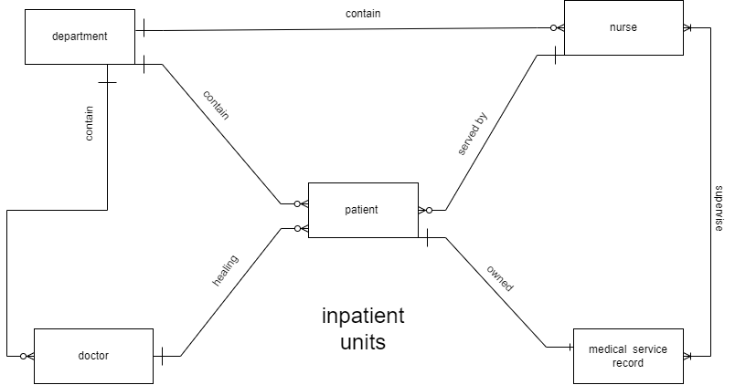

The graph is containing of two impotent components:

1_ the entities:

represented by the boxes it's the main components of our system.

2_ the relations: is what's the link between that components in the system

Derive to 3 different to:

* one to one
* one to many
* many to many

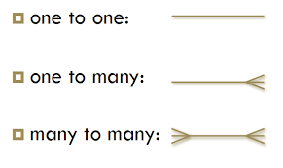

## Schema and Mapping

D: derived attributes

M: multi-value attributes

C: composite attributes

Department: (department_id(PK), name, email, phone)

Doctor: (doctor_id(PK), department_id(FK), Fname, Mname, Lname, gender, date_of_birth, salary, phone, email, degree type, graduated from, country_of_degree, specialty)

Doctor Address: (doctor_id, tax number, country, state, city, street name, building number)

Patient: (patient_id(PK), doctor_id(FK), fname, mname, lname, phone, gender, date_of_birth, room no, case description, disease type, medicine name).

Nurse: (nurse_id(PK), department_id(FK), doctor_id(FK), fname, mname, lname, gender, date_of_birth, salary, phone, email, degree type, graduated from, country_of_degree)

Nurse Address: (nurse_id, country, state, city, street name, building number)

Medical_Service_Record: (medical_service_record_number(PK), patient_id(FK), date_and_time, service_type, medicine name)

Service Management: (medical_service_record_number(FK, PK), nurse_id(FK,PK))

.

## Normalization

You need to use the table below for each normal form.

### 1st NF

You need to define what is the 1NF and when it is violated.

|  |  |  |  |
| --- | --- | --- | --- |
| Relations | Attributes | Violation description | Solution – Relations |
| Doctor has (doctor ID, tax number, salary, name, gender, date of birth, phone, email, address, degree type, graduated from, the county of the degree, specialty). | Name | Because this attributes is a composite attributes and that doesn't applied with the first normal form of the data base design | Doctor:(Fname,Mname,Lname,etc.) |
| patient has (Patient ID, name, phone, gender, date of birth, address, phones of the first degree relatives, room no, recovery plan, case description, disease type, medicine ID) | relative's phone | Because this attributes is a multi-value attributes and that doesn't applied with the first normal form of the data base design | Patient relative's phone (patient ID, first phone, second phone). |
| patient has (Patient ID, name, phone, gender, date of birth, address, phones of the first degree relatives, room no, recovery plan, case description, disease type, medicine ID) | recovery plan | Because this attributes is a composite attributes and that doesn't applied with the first normal form of the data base design contain first and middle and last name | Patient's recovery plan (patient ID, doctor ID, number of treating sessions, time of the sessions, medicine ID). |
| patient has (Patient ID, name, phone, gender, date of birth, address, phones of the first degree relatives, room no, recovery plan, case description, disease type, medicine ID) | Address | Because this attributes is a multi-value attributes and that doesn't applied with the first normal form of the data base design | Patient address: (patient ID, country, state, city, street name, building number). To have isolated entity |

### 2nd NF

You need to define what is the 2nd NF and when it is violated.

|  |  |  |  |
| --- | --- | --- | --- |
| Relations | FDs | Violation description | Solution – Relations |
| Doctor has (doctor ID, tax number, salary, name, gender, date of birth, phone, email, address, degree type, graduated from, the county of the degree, specialty). | The salary depends on the tax number while the rest of the attributes depends on the doctor ID that's called partial dependency | When it's become some attributes depends on part of the primary key and others on the second part of the primary key it's not computable with the second normal form | 1_ (doctor ID, name, gender, date of birth, phone, email, address, degree type, graduated from, the county of the degree, specialty).  Doctor  2_ (tax number, salary).  3_( doctor ID, tax number,salary). |

### 3rd NF

You need to define what is the 3rd NF and when it is violated.

|  |  |  |  |
| --- | --- | --- | --- |
| Relations | FDs | Violation description | Solution – Relations |
| the medical service record: (nurse ID, the medical service record number, Patient ID, date and time, service type, medicine ID). | Medical service record number, patient ID>>    Patient ID, medicine ID >>  Medical service record, medicine ID | The trinity functional dependency happened when get a relation between two attributes not dirtily by the prime key so the third normal form is to remove any trinity functional dependency | _(nurse ID, the medical service record number, Patient ID, date and time, service type).  _(patient ID, medicine ID) |

## Logical Design

1. Logical Design:

Database logical design: is the process of transforming a conceptual data model into a logical data model that can be implemented in a database management system.

The components of logical design:

1. Entity Names.
2. Entity Relationships.
3. Attributes.
4. Primary Keys.
5. Foreign Keys.
   1. Physical Design

The main goal of database logical design is to create a description of the data that will be stored in a database, along with the relationships between the data.

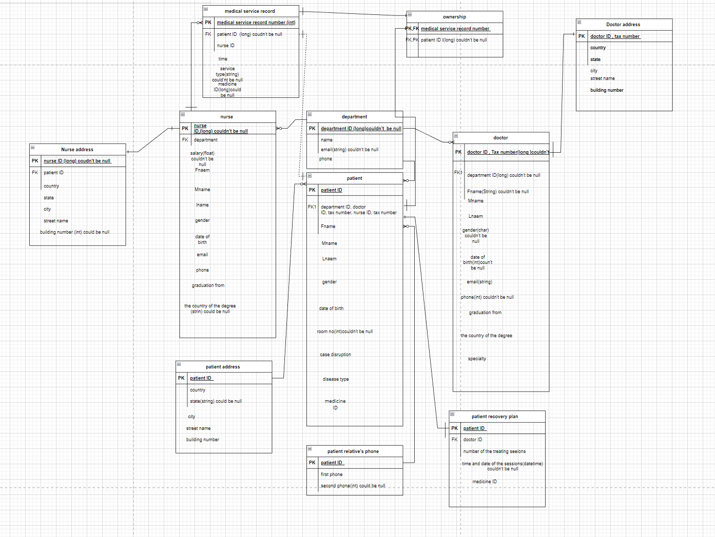

## Physical Design

Database physical design is the process of defining the physical structure of a database, including the storage media, file organization, indexing strategy, and other implementation details.

The components of Physical design:

1. Entity Names.
2. Entity Relationships.
3. Attributes.
4. Primary Keys.
5. Foreign Keys.
6. Attribute constraints.
7. Attribute Data Types.

The main goal of database physical design is to optimize database performance and ensure efficient data access and storage.

[The figure](logical.drawio):



## Effectiveness of the design

The usage and flexibility will be very high and will be stored all the required data that needed to make decisions and to be so clear with the patient and following up with the recovery plan also the continuously updating on the system by the doctor and nurse by checking tour and applying the medical record whom responsible of the patient the system will be esay going with any kind of expansion in the future.

# References

You need to write the references here using Harvard style of referencing.

*[solved] "students can enroll on many courses. A course can have many...: Course hero* (no date) *[Solved] "Students can enroll on many courses. A course can have many... | Course Hero*. Available at: https://www.coursehero.com/tutors-problems/MYSQL/40230265-Students-can-enroll-on-many-courses-A-course-can-have-many/ (Accessed: April 18, 2023).

Apilado, P. (2023) *The Johns Hopkins Hospital*, *Johns Hopkins Medicine, based in Baltimore, Maryland*. Available at: https://www.hopkinsmedicine.org/the_johns_hopkins_hospital/ (Accessed: April 18, 2023).